# RTL Better Cone – Tender Writing Support & Image Library

## A Sustainable Edge for Your Next Bid

RTL’s Better Cone Recycling Programme (launched in August 2025) is New Zealand’s first locally manufactured recycled road cone solution. The Better Cone programme’s environmental benefits and financial responsibility demonstrate a practical commitment to environmental stewardship that extends beyond policy statements.

* For every 1000 cones recycled through the Better Cone programme, approximately 5 metric tonnes of waste is diverted from NZ landfills
* Save approximately $1.50 per cone in landfill fees
* Support competitive pricing and local manufacturing

These metrics can assist in demonstrating your organisation’s commitment to reducing environmental impact while supporting local manufacturing and circular economy principles.

Incorporate specific language about your participation in New Zealand’s first closed-loop traffic cone recycling programme, highlighting the quantifiable reduction in landfill contribution:

# Example Text Tender Submissions (Paste & Personalise):

*"Our operations incorporate RTL's Better Cone recycling programme, New Zealand's first closed-loop solution for road cones. This partnership diverts approximately 5 metric tonnes of material from landfill per 1000 cones recycled while supporting local manufacturing. Our commitment to this programme aligns with* ***[insert relevant tender / contract sustainability framework]*** *and demonstrates our practical implementation of circular economy principles."*

# Factory Tour Available:

## See first-hand the machinery and recycling process behind creating cones from recycled material.

**Tour Testimony from** [**Michael Eremin Managing Director - Traffix**](https://www.linkedin.com/in/michael-eremin-56114916b?lipi=urn%3Ali%3Apage%3Aorganization_admin_admin_page_posts_published%3B35f2f941-e424-4101-8df8-ace964529ee6)

*“Thank you Talei and Cameron for the tour, very impressive operation.* ***As an industry we owe it to ourselves to clean up our act****, the majority of redundant cones out on the road and berms are stuffed and no longer compliant which is why they get left behind.* ***Here's an awesome opportunity for us all to do our bit*** *to pick them up in our areas as we see them and bring them in for a useful purpose. Happy to be part of an organised system to do this and bring in some loads on others behalf as well, let's keep discussing this and sort something out”.*

# Reference Links:

* <https://rtl.co.nz/post/rtl-launch-better-cone-recycling-programme>
* <https://rtl.co.nz/sustainability>
* <https://rtl.co.nz/resource/rtl-cone-recycling-policy-and-acceptance-criteria>

# Image Library:

## These high-res images are available for use in your tender submission.

**Right Click Save as:**

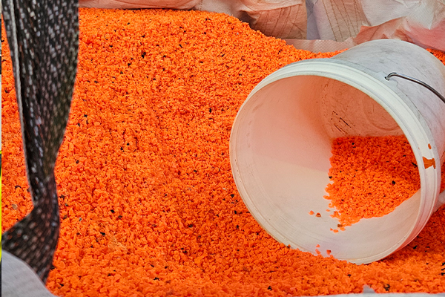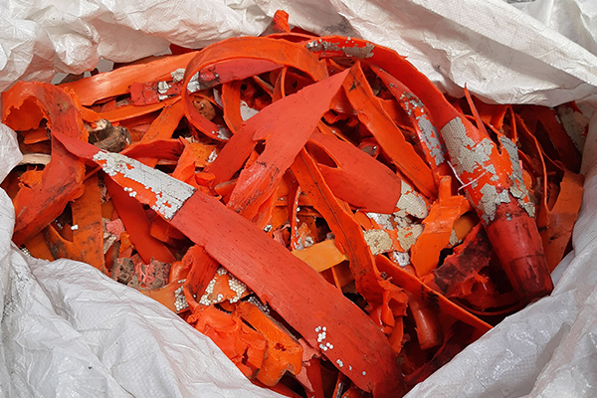

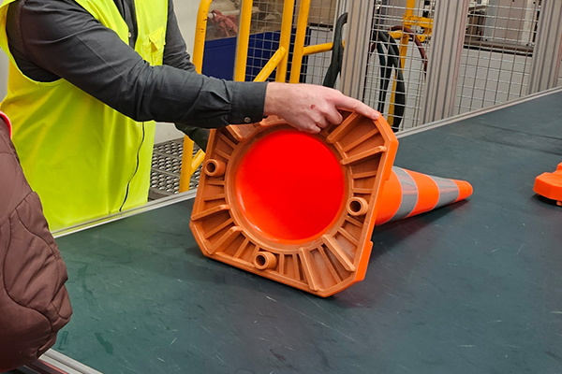

The images are 600px x 400px.